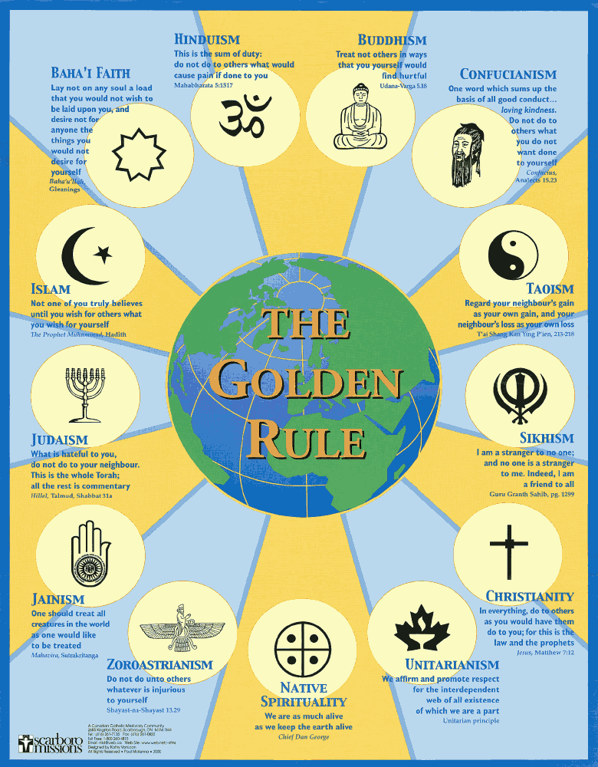
The American Muslims realizes that there is more than one path to salvation. We are all born by chance of birth into whatever faith we are born in. Generally everyone follows the faith of their parents. However, this does not mean that a person does not have the right to change their religion. Freedom of religion is fundamental to understanding and supporting Pluralism and Diversity. The Quran also protects religious freedom in 2:256.

On Pluralism and Diversity of human race no further proof is required than the following verse in the Quran 5:48. If this verse is preached from the pulpit then this message can be used to educate the common people too. Conservative religionists do not give importance to such diversity and pluralism. This is what we American Muslims are trying to change it.

QURAN RECOGNISES DIVERSITY & PLURALISM

To you WE have given the scriptures, just as WE have given the scriptures to people before you (Jews, Christians, Hindus, Buddhists, etc). We have protected your scriptures (Quran) in its entirety. So judge among people from what knowledge has come to you (from Quran) and follow not their vain desires (that Muslims are the only righteous and chosen people to lead) diverging far away from the TRUTH .
To each among you (referring to diverse groups – not excluding anybody) We have prescribed the Law (teachings of the indigenous, native people and Buddhist scholars, Gitas, Vedas, Torah, Gospels and The Quran) and an Open Way (given a conscience with reference to the spiritualists people).
If God had willed, all humanity would have been of one single community (this means diversity is part of God’s creation). God’s plan is to test you in what each one has received (in form of Holy Scriptures or Conscience). So strive, as in a race in all virtues.
The goal of all the people is to God. God (alone) will tell you the truth in matters of which you dispute.” 5:48
Every People have received Apostle/Prophets
The following verse in the Quran is repeated 3 times. These are very important verses that further the teachings of Diversity and Pluralism in the Quran.
The Quran says, “To every people was sent an Apostle to teach them in their own language in their own country – making things clear” 10:47, 14:4 & 16:36. This means that numerous Prophets have been coming from the beginning of times to guide people for living a righteous life. Our Prophet has said there are 124,000 Prophets (numerous) that have been send from time to time to different people all over the world. Each Prophet preached the same message of believing in God and doing righteous acts. This would mean that Confucius, Buddha, Ram, Krishna could also be Prophets for Buddhists and Hindus too. Their Holy Scriptures is also just as important as the Abrahamic Scriptures, namely, The Torah, The Gospels and The Quran.

Pluralism is further strengthened where there is Equality of all The Prophets, and this is exactly what the Quran says in 4 different verses. Conservative religionists create problems when they put Prophet Mohammed ahead and over and above all other Prophets. Muslims are never to grade Prophets at all. We have to consider all of them Equal. By this teaching, equality is also transferred to their respective followers, be they Jews, Christians, Hindus or Buddhists, etc. This kind of thinking further consolidates the teachings of Pluralism and Diversity that is so much needed in 21st century. The below quotation speaks openly about Equality of All the Prophets.
EQUALITY OF ALL PROPHETS
The Quran iterates equality of all the prophets in front of God, although each prophet was gifted in different ways, carrying messages at different times, in different conditions and to different people: “We believe in the revelation given to us, and the revelation given to Abraham, Ismael, Issac, Jacob and the tribes, and the revelations given to Moses and Jesus, and that given to all the Prophets from their Lord. We make no difference between one and another of them. We bow to God in Islam.” 2:136, 2:85, 3:84, 4:152.

Salvation for Anyone and Everyone who is Righteous:
I especially want to convey to you that God will reward anyone believer from any religious tradition according to the following verse in the Quran which is repeated 3 times in different places.
“Those who believe (in the Quran), those who follow the Jewish Scriptures, the Christians (who follow the teachings of the Gospels) and the Sabians (followers of John the Baptist or Zoroastrians), any (Hindu, Buddhist, spiritualists, etc. (anyone living in any part of the world) who believe in God, the Last Day and work righteousness, shall have their reward from their Lord, on them shall be no fear, nor shall they grieve.” 2:62, 5:69, 2:112 (repeated numerous times all over the Quran)
Conclusion:
Pluralism and Diversity is the core message in the Quran. It acknowledges Equality of All Believers and further guarantees “rewards” for any who believe in God, the Day of Judgment and who does righteousness. This is in complete compliance with the Golden Rule Poster.
Iftekhar Hai, President
UMA Interfaith Alliance
www.umaia.net

